Social Distancing & Mask Monitor Drone For COVID Prevention

In 2019 a strong pandemic started gripping the world. By mid 2020 almost every country on the face of the search had been affected and had lockdowns in place. To stop the spread of this highly infectious disease, it is important to ensure people wear mask in public and follow social distancing norms.
To ensure masks compulsion and social distancing, constant policing and monitoring is necessary and constant reminders to offenders. To ease this task we here design a drone that can patrol long distances easily and ensure social distancing as well as mask are worn in public places.
Our specially designed drone makes use of a controller based circuit system coupled with 4x High RPM quadcoptor motors for easy navigation and control. RC control to ensure long range flying. An FP camera with transmitter to transmit live footage. A loudspeaker and voice receiver to scold/warn offenders remotely via the drone as soon as they are spotted.
The drone can be used to remotely monitor for covid 19 restriction violations and issue warnings remotely through loudspeakers. This will help in easy monitoring/patrolling of large areas /long streets bby the use of drones.

Components

- Atmega Microcontroller
- PDB Board
- Motion Controller
- FP Camera
- RC Transmitter
- RC Receiver
- RC Remote
- Drone Frame
- Drone Rotors
- Drone Propellers
- Resistors
- Capacitors
- Diodes
- IC & Transistors
- PCB
- Supporting Frame
- Screws & Joints

Applications:

- Streets
- Parks
- Queues
- Public Places

Advantages:

- Easy to Use
- Automatic Operation
- Easy to Give Warnings
- Easy to Monitor

Disadvantages:

- Limited Battery Life

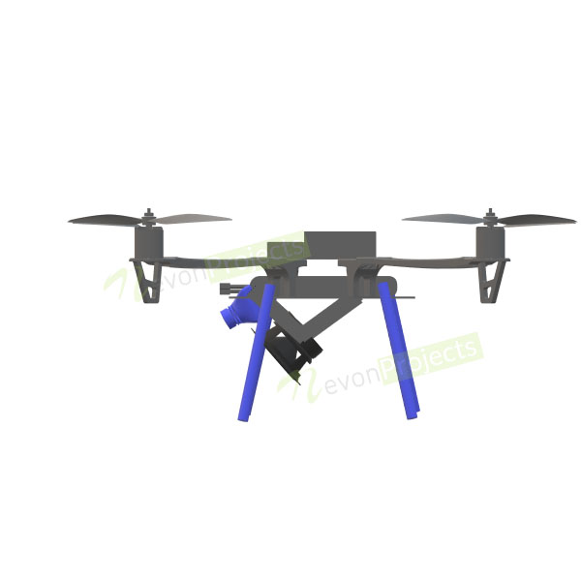
Block Diagrams

